Crucible

User Interface Design Document

# Contents:

# Introduction

* 1. Purpose of this document
  2. References

1. User Interface Standards
2. User Interface Walkthrough
   1. Medals and Images
   2. Menus
3. Data Validation
4. **Introduction**
   1. Purpose of this document

This document will contain critical information focused on the user experience and the inference that the user interfaces with while using the application. In addition, this document will also contain tools and standards that were used as references for this document. This shall be located within the section labeled references and numbered 1.2. Section 2 of this document will contain the standards for the user interface. These specifics will contain information that will grant the reader the design standards of the user interface and provide an overview of what input will cause specified actions. It will also contain various menus within different pages of the user interface to provide the most in-depth details possible. The Third section of this document shall contain diagrams of how different pages can be reached and also how menus will branch based on user input within the interface. It shall also contain screenshots of the pages of the interface and will be the best representation of these pages that we as the Crucible team intend to implement. Section 4 will give a full description of all the possible inputs that the user might input into the system. This section will provide diagrams of the logic behind the input validation and also show what type of data the input shall expect and what will happen should the input not match the expected input. For section 5 the application shall display reports within the application and these will be based on the user’s interactions within the application themselves therefore, it shall display a templated format of the monthly report that the user shall see. Therefore, we have nothing that needs to be put in section 5.

* 1. References

[A Comprehensive Guide To UI Design — Smashing Magazine](https://www.smashingmagazine.com/2018/02/comprehensive-guide-ui-design/)

The Smashing Magazine document has many important points to consider especially when creating a new application. An example of this is the importance of maintaining consistent typography, images and media, and forms of data input and output. Therefore, we find that this is a piece of critical information that we need to consider.

[Planning your iOS app - Apple Developer](https://developer.apple.com/ios/planning/)

The official Apple documentation for planning and executing an iOS. The link contains guides on how to successfully create an app and design an interactive design to keep your users engaged and with an easy-to-understand layout.

1. **User interface Standards**

We as the Crucible team have found it evident to establish both effectively clear and concise documentation discussing the standards that will be used throughout the application. Within this section of the interface, the document shall present information that concerns the user’s experience and also the standards the Crucible team will maintain in order to make the interface as easy to understand as possible. In addition, any designs and illustrations shall not be indicative of the final product. This is because although we as a team have decided what the basic functionality, layout, and colors of the application will be it does not mean that this is not currently subject to change. Therefore, this section shall display what we as the Crucible team have designed for now and will also display our thought process behind the arrangement of interactable pieces and the layout itself.

The Home Screen

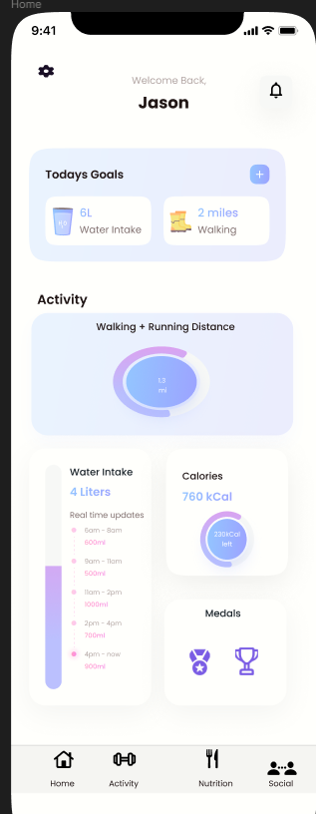

The definitive layout of the home screen is arguably the most important screen, this is because the user will typically interact based on this screen and have the most number of interactions with it. Therefore, we found it to be exceedingly important to make the screen as easy to understand as possible, and also be able to interact with all portions of the application. That being said, we started with the pages at the bottom of the screen. This is an intuitive design because it makes switching between pages very easy. In addition, we have pictures and writing for each page because it makes it known exactly what button goes to which page. In addition, at the top of the screen, we have our settings button represented by a gear, and the notifications button represented by a bell. These are only represented by symbols because they have become synonymous with these symbols in our modern world. Also, at the top of the screen is our Welcome Back message. We found this to be important because it allows us as a team to connect with our users and also gives them positive reinforcement about using our application. Just below that, we have our Goals tab. We thought as a team that this would be important to put it at the top so the user sees it second and it is in an easy place to access and interact with. In accordance, we oriented our critical information about it page within our application just below that. We wanted to place these in an easily accessible and reachable place where users could quickly and effortlessly check their progress in their nutrition, fitness, or water goals. We also added the medal tab to again promote positive reinforcement of their fitness goals and help the end user feel more positive about their goals.

Key access points for the home page are each of the page switching buttons at the bottom of the screen because these are critical. In addition, we seek to maintain their positions across our different tabs to maintain consistency as well as make it easy for users to memorize the layout of the bottom tabs. Again we expect users to consistently navigate through both the settings and the notifications buttons because the user may wish to change settings or notifications therefore, we have put them in easily accessible locations. Lastly, we have the graphs that are taken from the different pages water intake, calories consumed, and also the nutritional graph. We expect users to be able to access these graphical displays and see the information that these graphs provide in more detail and the user could get even more information by switching to the desired page matching the graph that they wish to look at.

The Settings Page

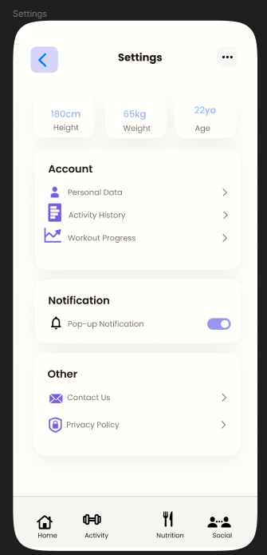

The settings is another critical feature that we will have within our application. This page can be accessed by selecting the gear icon at the top of the “main” screen. We found this to be the most logical location for the settings menu. In addition to this, the setting menu will allow the user to access their personal data as well as change settings. However, we find this also the most logical location as well to have our policies and contact information for ease of use and reducing the amount of clutter on each screen.

1. **User interface Walkthrough**

The below figure represents the average user interface experience of the user from when they download and start the app to when they close out the app. The user Starts with an opening screen where they put in their first-time information (name, email, and password). The user will then see another screen in which they will input their gender, DOB, weight, and height. When users come back to the app, they will encounter the login screen. The login screen is where the user will be able to input the email address that they used to sign up and their password.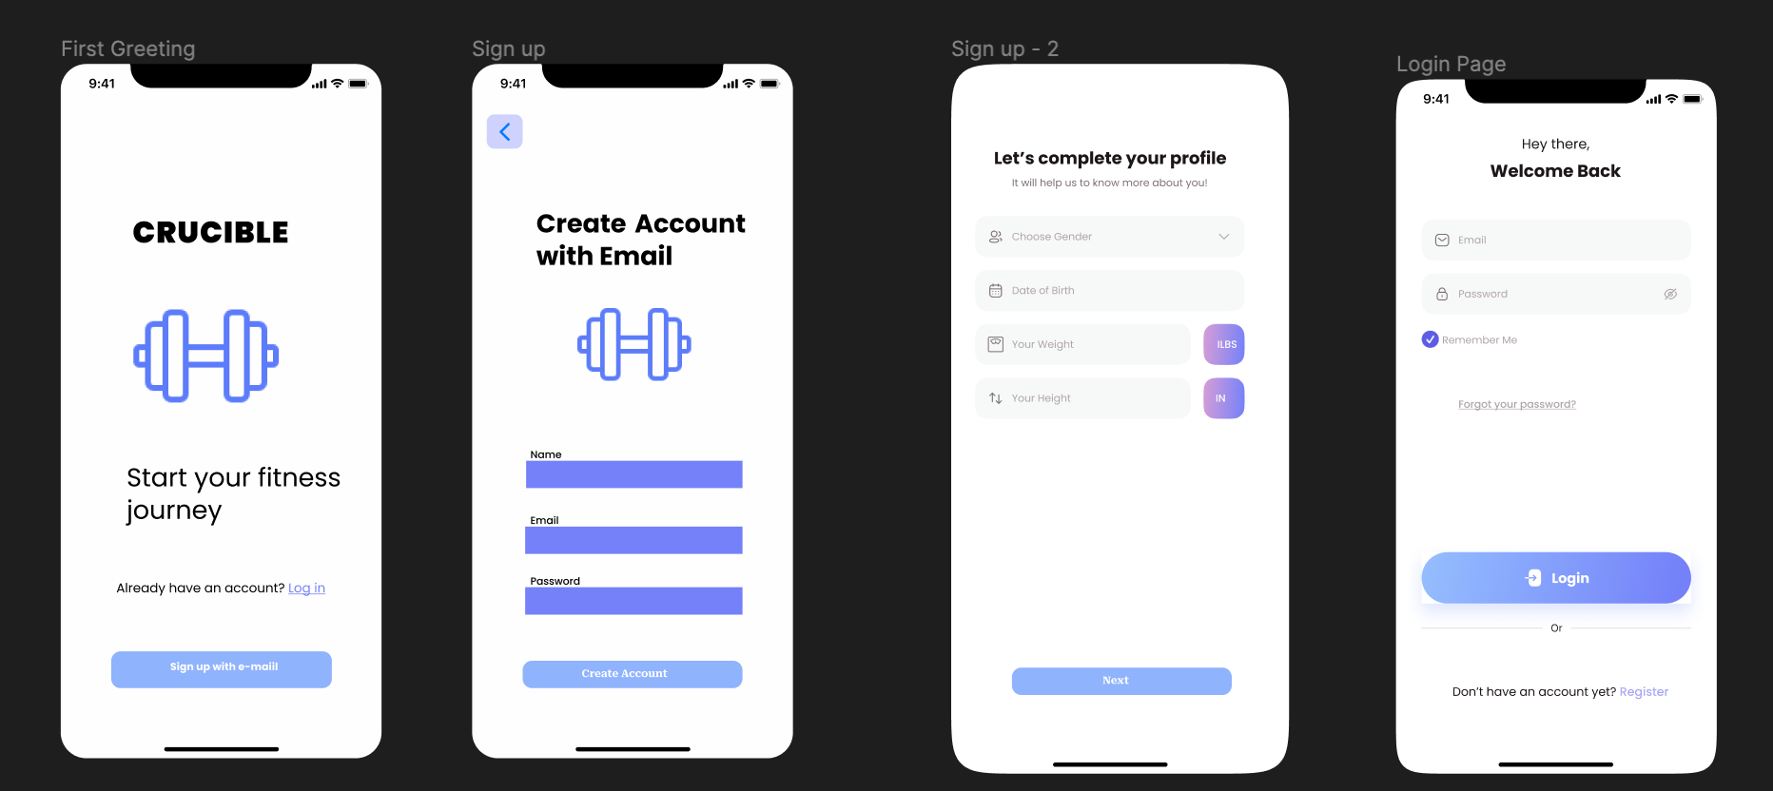

After the user clicks on the Login button, they will be sent to the home screen. The home screen will contain various components. The user will see a welcome message and various other components. The first component is called Today Goals. In this section, users will be able to see what their goals for the day are. For example, in the image below, the user’s goals are to drink 6 liters of water and to walk 2 miles. In the activity component, users will be able to see how many miles they have run/walked throughout the day. In the water intake component, users will be able to see how much water they have consumed throughout the day. The calories component will show the user how many calories they have consumed, and the medals component will show the user the medals they have earned.

Users will be able to click on the Gear icon, located on the left-hand side of the Home screen. The gear icon takes the users to the Settings page, where they will be able to see various information about themselves (height, weight, age). They will be able to disable notification popups and view their workout progress, and activity history. To go back to a previous screen, the users will be able to press the blue arrow. On the right-hand side of the screen, users will be able to press the Bell icon. The Bell icon will transfer the users to their notifications. They will be able to see notifications that have been sent to them by the Crucible app.

At the bottom of the screen, the user will be able to view a Tab bar that will allow them to navigate to the other screens of the app, such as the Activity or Nutrition screens.

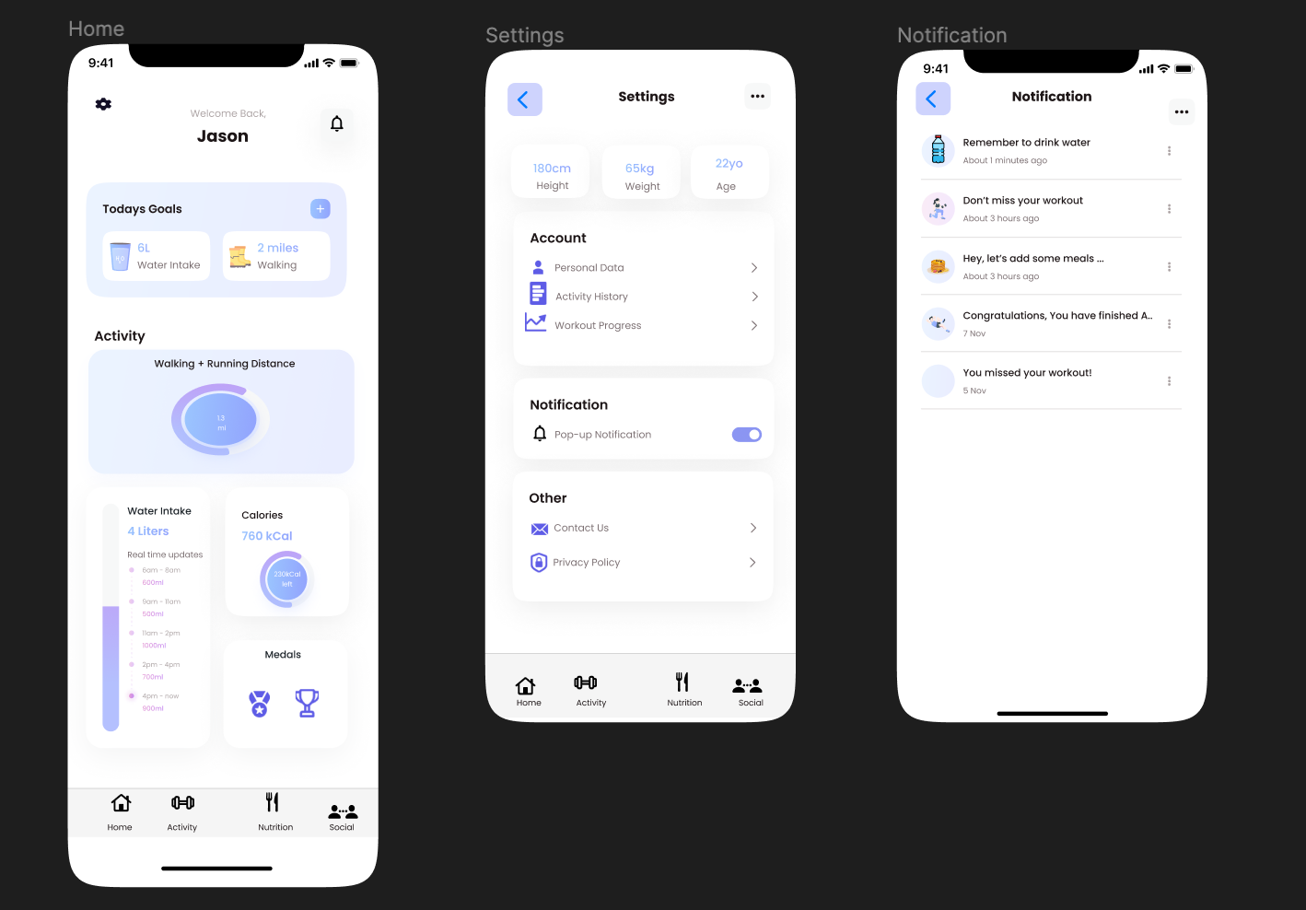

The image below shows the possible pages that the user will be able to navigate to. If the Activity button is clicked, then they will be in the Activity screen where they will be able to add exercises. In the Activity screen, users will be able to view the exercises done for the day. The leftmost image shows that the user has entered Squats, Bench, and Pull-ups as their activities of the day. Each exercise will display how many sets were completed with the volume of that set done. The bar chart displays the Total Volume of exercise performed by the User. The weekly button shows the Total Volume for that week. If a user wants to add an activity, they can simply click on the Add Activity button. When this button is clicked, the user will be able to input the name of an exercise, number of sets, number of reps, and weight performed. Users can also navigate to the Nutrition screen where they can view their meals of the day separated by Breakfast, Lunch, and Dinner sections. Users will be able to input various meals per section such as the name of the meal, calories, water, protein, carbs, etc. The Nutrition page will show the user a pie chart, breaking down their most important macros, such as Fat, Carbs, and Protein. They will also view a calendar where they will be able to view their meals from previous days.

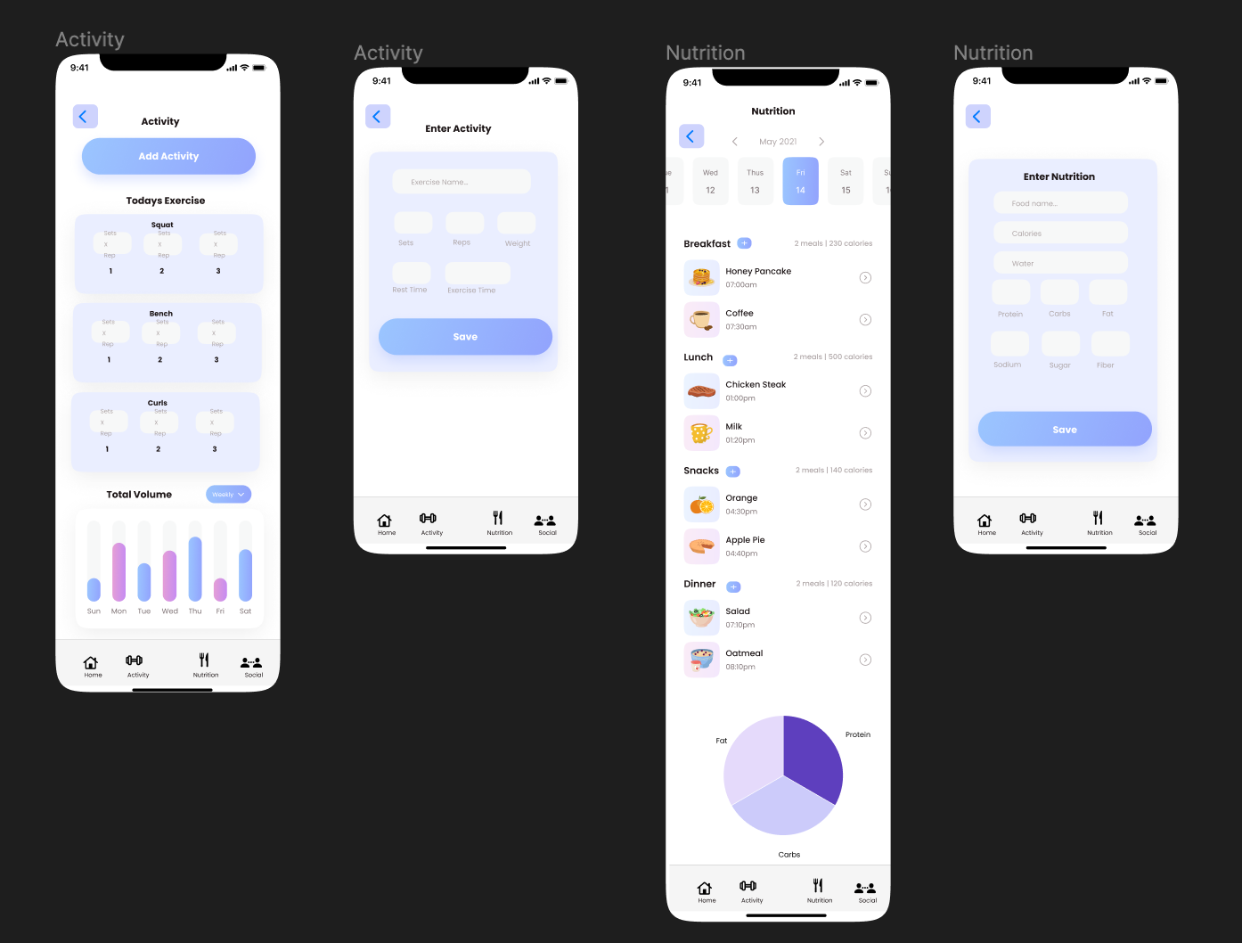

1. **Data Validation**

| Data Item Table | | | |
| --- | --- | --- | --- |
| Name | Type | Limits | Formats |
| Username | String |  |  |
| Age | Int | Age > 0 & Age < 200 | Age in Years |
| weight | double | Weight > 0 | Weight in pounds or KGs |
| InLBS | bool | Defaults to True | True or False |
| Height | double | Height > 0 | Height in inches |
| isMale | bool | N/A | True or False |
| Birthday | int | Birthday > 0 & Birthday < 365 | In days |
| SendDaily | bool | Random within the day. | True or False |
| MonthlyReportCountdown | double | countdown<=30 | Defaults to 30 |
| MonthlyReset | bool | Every 30 days | True or False |
| DailyReminderCountdown | double | Every 24 hours  At 00:00. |  |
| CalorieReset | double | Every 24 hours, at 00:00. |  |
| Medals | PNG | Medal Exists | PNG |
| Quests | Quest | N/A | Class object |
| ActivityName | string | N/A | Name of workout |
| Reps | int | >0 |  |
| sets | int | >0 |  |
| Total weight | double | >0 | In LBS or KGs |
| Rest time | double | >0 | In seconds/minutes/hours |
| Exercise time | double | >0 | In seconds/minutes/hours |
| Carbohydrates | Double | >= 0 | Grams |
| Protein | Double | >= 0 | Grams |
| Fats | Double | >= 0 | Grams |
| water | Double | >= 0 | Fluid ounces |
| Sodium | Double | >= 0 | Milligrams |
| Calories | Double | >= 0 | kcals |
| TotalSugar | Double | >= 0 | Grams |
| TotalFats | double | >= 0 | Grams |

Appendix A

Agreement Between Customer and Contractor

The team and our customers are agreeing to have a fitness app created that will allow the user to track their exercise and see how many calories they ate during the day. The app will be secure, and users can securely share their workouts with other people who use the software. There will be no transaction between the user and the team without notifying them and asking them to pay for our app. Also, the customer has to approve the use of their workouts being tracked when on the fitness application. The customer will receive a working app when they download it and we can address any issues they have after they use the features that we have.

Our group knows that there could be future additions to this document and parts of the app may not be developed. In the event that we have to change this form, we will notify the customer and make sure they approve the new requirements we have and would work with them to have the best application we can build. The way we will make sure they participate in all aspects of the development process and also be notified of any and all changes that the team may wish to implement. In addition, the Crucible project team will be subjected to creating update reports should the requirements change in a vast manner that shall be produced in a timely manner. Should the customer require any modifications of the system that they wish to implement they can submit a written document that shall entail the details and specifications of the changes that they will desire. However, these changes may or may not be approved by the Crucible team under the circumstances of cost, and time. However, should the changes be necessary they shall be implemented with a new timeframe of development and release to the customer. In addition, should the change be infeasible to implement within the release timeframe, an update can be developed for the Crucible application and this update will be released after the initial agreed-upon release date, however, the update shall take precedence with suggested changes for the application. Lastly, both parties must agree upon large changes within the application. This is to mitigate the amount of time that is required to develop the application. In addition, the development team has oversight as well as responsibility for their respective domains and the development of the Crucible application.

## Signing below acknowledges the facts that are denoted above and I do accept on behalf of myself or the company I represent has read and approves of everything outlined above.

## Customer Signature: X_____________________________________________________

## Appendix B – Team Review Sign-off

All Members of the Crucible team have read and reviewed this document and have agreed on the content and format.

I [Miles Wilson](mailto:milesw1@umbc.edu) do affirm that I have read and understood the contents of this document and as well do actualize the fact that this document will contain information that declares what is expected of myself and my teammates.

X_____________________________________________________ Date:_____________

I [Michael Duong](mailto:mduong2@umbc.edu)do affirm that I have read and understood the contents of this document and as well do actualize the fact that this document will contain information that declares what is expected of myself and my teammates.

X_____________________________________________________ Date:_____________

I [Aryan Singh](mailto:arysin1@umbc.edu)do affirm that I have read and understood the contents of this document and as well do actualize the fact that this document will contain information that declares what is expected of myself and my teammates.

X_____________________________________________________ Date:_____________

I [Tommy Stinson](mailto:tstinso1@umbc.edu) do affirm that I have read and understood the contents of this document and as well do actualize the fact that this document will contain information that declares what is expected of myself and my teammates.

X_____________________________________________________ Date:_____________

I, [Jason Garcia Solorzano](mailto:jgarcia8@umbc.edu)do affirm that I have read and understood the contents of this document and as well do actualize the fact that this document will contain information that declares what is expected of myself and my teammates.

X_____________________________________________________ Date:_____________

## Appendix C – Document Contributions

This section holds the individual contributions of each team member and an estimation of what percentage each member has contributed to the writing.

Tommy - Section 4 25%

Miles - Appendices, Section 4 25%

Michael - Section 1, Section 4 25%, Section 2

Jason - Section 3 50%, Section 4, 25 %

Aryan -